

NOVAC TECHNOLOGY SOLUTIONS

User Manual

Document Version No.: 1.00

Revision History
Version No | Reason For Changes | Author | Approver
0.01 | Draft | Anurag Kumar
1.00 | Reviewed & Approved the User Manual | Anurag Kumar | NIJANTHAN PL

Table of Contents
1. Introduction 4

2. Data privacy Clause 4

Introduction

As per the requirement, System should mandate the data privacy warrantees for Motor and Fire Product.
- Guidelines, circulars, instructions and directions released from time to time by Philippines Insurance council.

Data privacy Clause

- System should mandate the data privacy warranties for Motor and Fire Product. System should follow the existing wordings of data privacy warranties.
In Motor Product Data privacy clause(Motor Proposal)
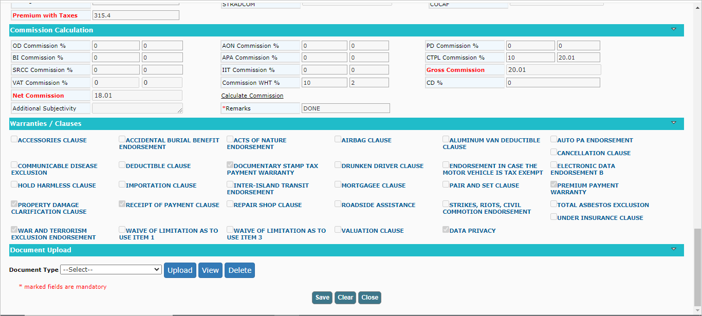

In FIRE Product Data privacy clause(Fire Proposal)
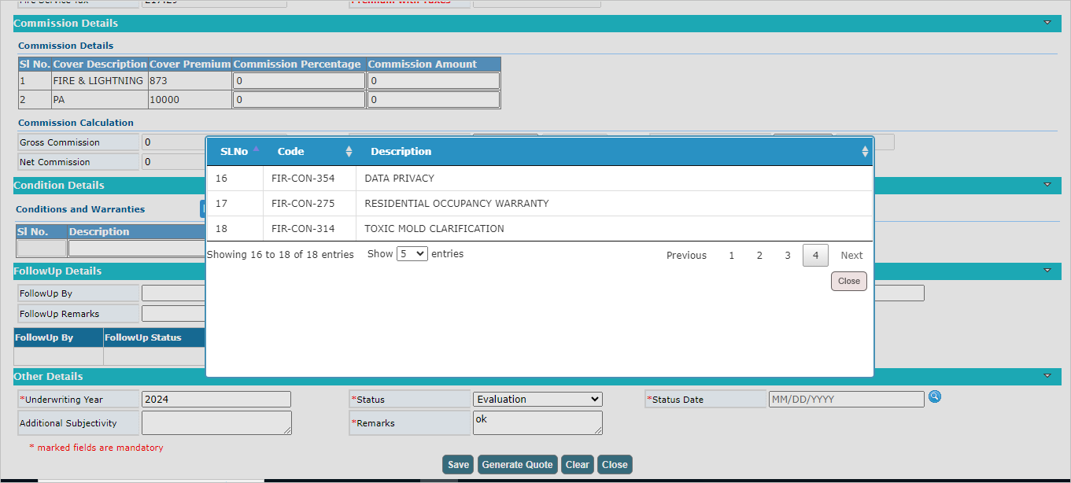
Now Click on close button to close the window.

